What makes a home a home .
- A home is a place where you are surrounded by people who love and care about and people you love and care about.
Where is my feature home?
- My home has always been Massachusetts. I would like to live around Fall River.
What's my dream home?
- Cost of house $328,200
- Down payment 67,980
- Monthly payment $2,159
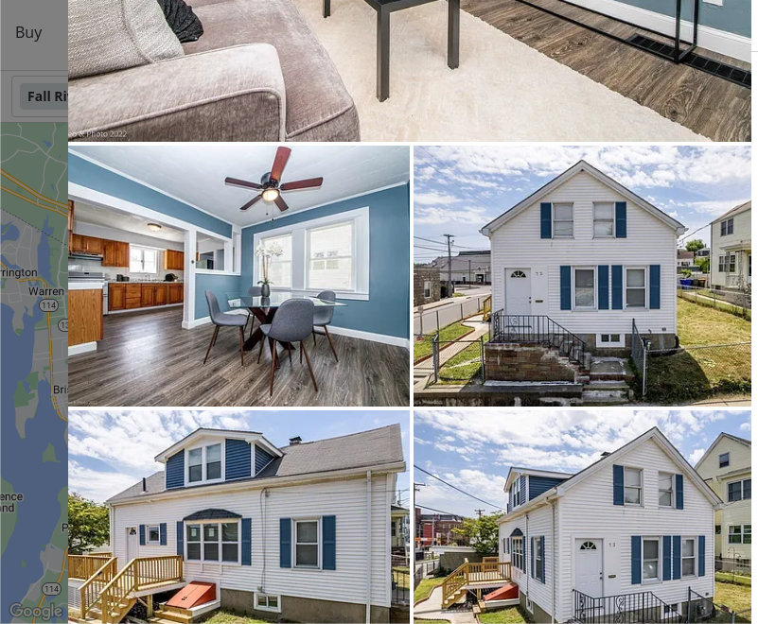
What's my dream car?
- Cost of car- $22,998
- Down payment- $2,000
- Monthly payment- $365 - $408
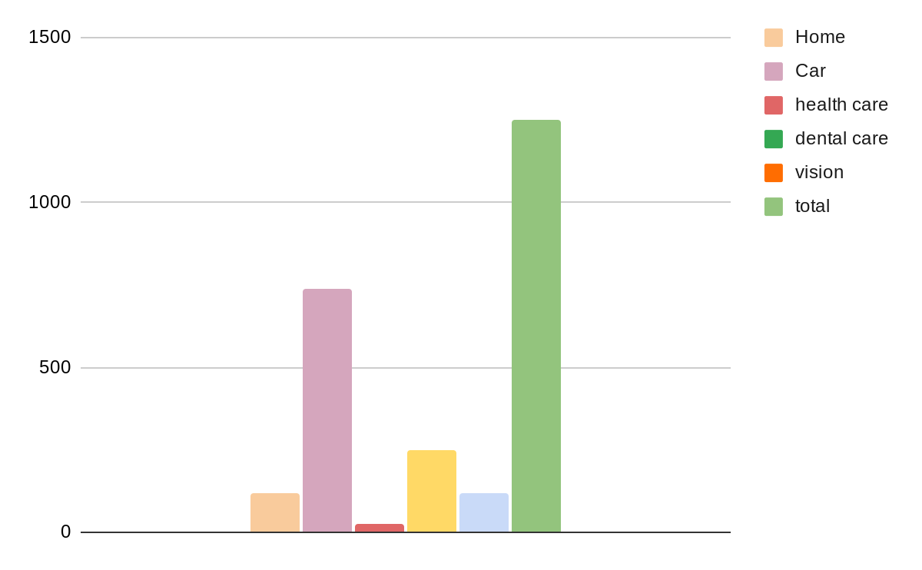
Renting:
Renting a dream home-
- 75 a day
- Incruence - 138 yearly/ 12 monthly

Renting a car-
27 a day for a standard car
34 yearly

